Code Pipeline With S3

<https://www.youtube.com/watch?v=KCcoQ7GBra8>

Code Pipeline with EC2

<https://www.youtube.com/watch?v=NwzJCSPSPZs>

CI/CD Pipeline with AWS CodePipeline, AWS CodeCommit, AWS CodeBuild, and AWS CodeDeploy

<https://www.youtube.com/watch?v=NCXzTgjUOQo>

# Set up your first AWS CodeCommit Repository

If unable access repository then use following comment

**git config --global credential.helper '!aws codecommit credential-helper $@'**  
**git config --global credential.UseHttpPath true**

<https://www.youtube.com/watch?v=E1GJqfIEJkM>

Serverless api

<https://www.youtube.com/watch?v=Ut5CkSz6NR0&t=310s>

Lombard Api

https://www.youtube.com/watch?v=OhEANj3Y6ZQ

Git Repository

<https://www.youtube.com/watch?v=Fk12ELJ9Bww>

1. <https://www.youtube.com/watch?v=OVL7R0eT8jw>

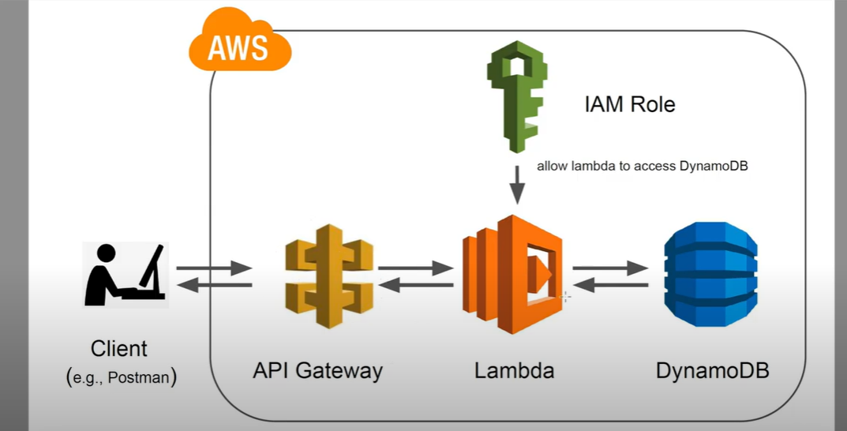

Step 1 : Create DB on DynamoDB

Step 2: Create API instance on Lambda

Step 3:assign role to Lambda like fullCloudWatchAccess and fullDynamoDBAccess

Step 4:create instance on API gateway and deploy

Step 5 : instert code on Lambda